**IBM** **ASSIGNMENT** **-** **1**

|  |  |
| --- | --- |
| Team ID | PNT2022TMID50823 |
| Project Name | Smart crop protection system for agriculture |

**Thinkercad** **with** **2** **sensors,** **an,Led,** **buzzer** **:**

Let's learn how to control multiple LEDs using Arduino’s digital outputs and a breadboard. Expanding upon the [last lesson on blinking an LED](https://www.instructables.com/id/Blink-an-LED-With-Arduino-in-Tinkercad/), We'll

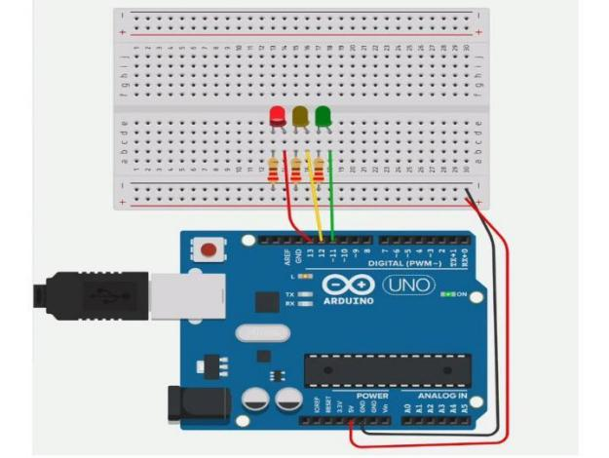

connect some LEDs to the Arduino Uno and compose a simple program to light them up in a pattern.

You can follow along virtually using [Tinkercad Circuits](https://www.tinkercad.com/circuits). You can even [view this lesson from within Tinkercad](https://www.tinkercad.com/things/newv2?tenant=circuits&lessonid=ELB4FYAJD0K8TZV&projectid=O6QUTPNJDUKI7RD&collectionid=OMOZACHJ9IR8LRE&title=Multiple%20LEDs%20&%20Breadboards) if you like! Explore the sample

circuit and build your own right next to it! Explore the sample circuit in the

workplane, and build your own along side it. Tinkercad Circuits is a free

browser-based program that lets you build and simulate circuits. It's perfect for [learning](https://www.tinkercad.com/learn/),[teaching](https://www.tinkercad.com/teach), and prototyping.

o

